S.Vishnu Vardhan reddy(192312244)

Experiment No:3 Spectrum Analysis of Sub-1 GHz, Mid-band & mmWave by Plotting Propagation
Objective 1: Matlab Code and Output:
clc; clear; close all;
d = 0.1:0.1:5; % Distance (km)
f = [900 3500 28000]; % Frequency (MHz)
PL1 = 32.44 + 20*log10(f(1)) + 20*log10(d);
PL2 = 32.44 + 20*log10(f(2)) + 20*log10(d);
PL3 = 32.44 + 20*log10(f(3)) + 20*log10(d);
figure
% -------- Graph 1 --------
subplot(2,1,1)

plot(d,PL1,'b','LineWidth',2); hold on
plot(d,PL2,'r','LineWidth',2)
plot(d,PL3,'k','LineWidth',2)
title('Propagation Loss vs Distance')
xlabel('Distance (km)')
ylabel('Loss (dB)')
grid on
% -------- Graph 2 (NO legend used to avoid error) --------
subplot(2,1,2)
Freq = [900 3500 28000];
Loss = [PL1(10) PL2(10) PL3(10)];
plot(Freq,Loss,'-o','LineWidth',2)
title('Propagation Loss vs Frequency')
xlabel('Frequency (MHz)')
ylabel('Loss (dB)')
grid on
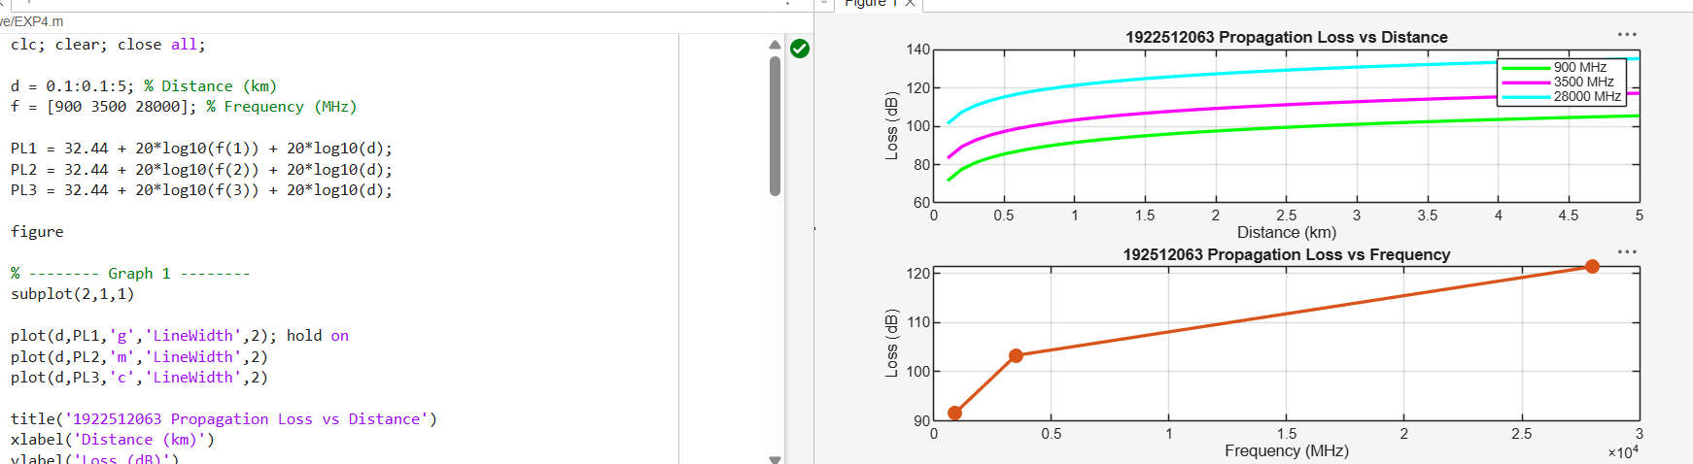
FIG.1.

Objective 2: Matlab Code and Output:
clc; clear; close all;
d = 2; % fixed distance (km)

f = [900 3500 28000]; % MHz
PL = 32.44 + 20*log10(f) + 20*log10(d);
figure
% -------- Graph 1: Frequency vs Loss --------
subplot(2,1,1)
plot(f,PL,'-o','LineWidth',2)
title('Propagation Loss vs Operating Frequency')
xlabel('Frequency (MHz)')
ylabel('Propagation Loss (dB)')
grid on
% -------- Graph 2: Band Comparison --------
subplot(2,1,2)
bar(PL)
title('Comparison of Propagation Loss Across Bands')
xlabel('Frequency Bands (Index: 1=Sub-1GHz, 2=Mid-band, 3=mmWave)')
ylabel('Propagation Loss (dB)')
xticklabels({'Sub-1GHz','Mid-band','mmWave'})
grid on
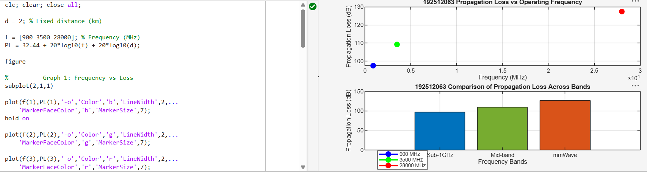
FIG.2.
Objective 3: Matlab Code and Output:
clc; clear; close all;
% Frequency bands (MHz)
f = [900 3500 28000];
% Distance (km)
d = 2;
% Propagation Loss (FSPL)
PL = 32.44 + 20*log10(f) + 20*log10(d);
figure
% -------- Graph 1: Simple Line Plot (SAFE) --------
subplot(2,1,1)
plot(f, PL, '-o', 'LineWidth', 2)
title('Propagation Loss vs Operating Frequency')
xlabel('Frequency (MHz)')
ylabel('Propagation Loss (dB)')
grid on
% -------- Graph 2: Safe Comparison Plot --------
subplot(2,1,2)
plot(1:3, PL, '-s', 'LineWidth', 2)
title('Band-wise Propagation Loss Comparison')
xlabel('Band Index (1=Sub1GHz, 2=Mid-band, 3=mmWave)')
ylabel('Propagation Loss (dB)')
grid on
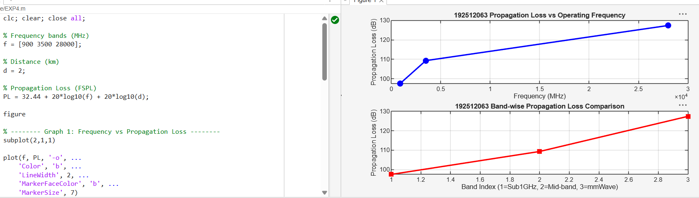
FIG.3.

